Test Case: tc007_SPX_Dev5_Validacion_Boton_Edit_Administrador_Menu
Step 1 - Enter username and password and click to button Enter : Credentials Entered
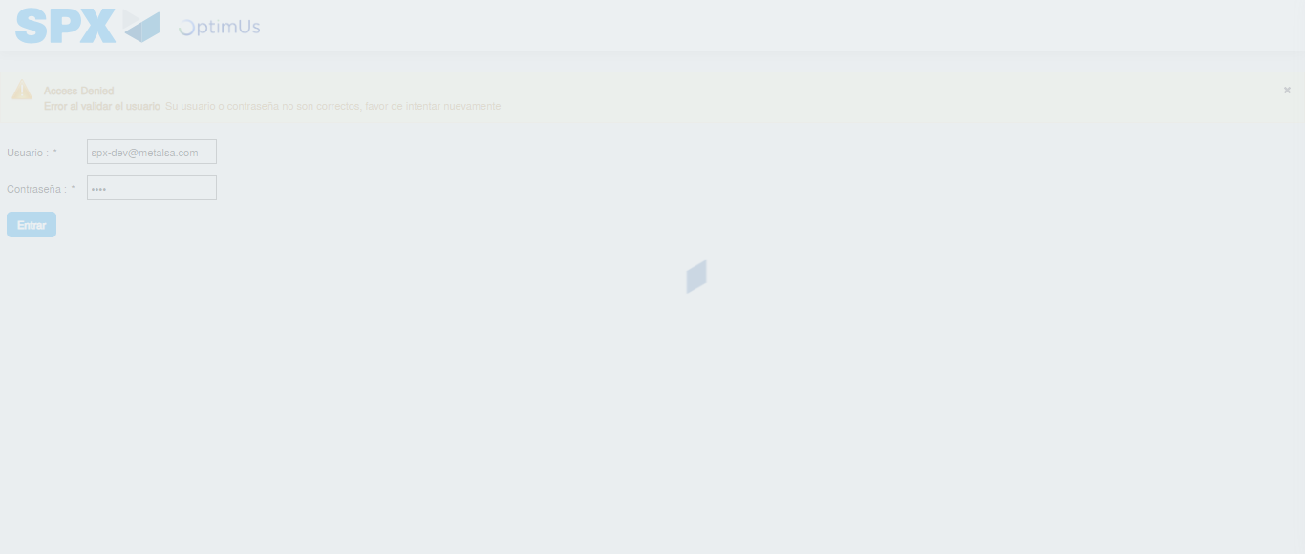Image file-name: QC_Testing-tc007_SPX_Dev5_Validacion_Boton_Edit_Administrador_Menu-nov. 20 2025, 03 43 11 p. m.

Step 2 - Select to UEN and Access to Administrador Roles Menu: UEN Correctly selected and Correct access
Image file-name: QC_Testing-tc007_SPX_Dev5_Validacion_Boton_Edit_Administrador_Menu-nov. 20 2025, 03 43 15 p. m.

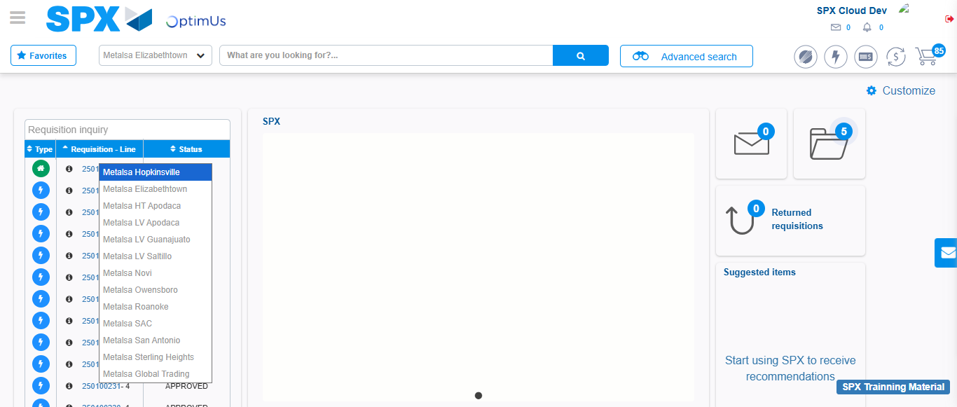Image file-name: QC_Testing-tc007_SPX_Dev5_Validacion_Boton_Edit_Administrador_Menu-nov. 20 2025, 03 43 21 p. m.

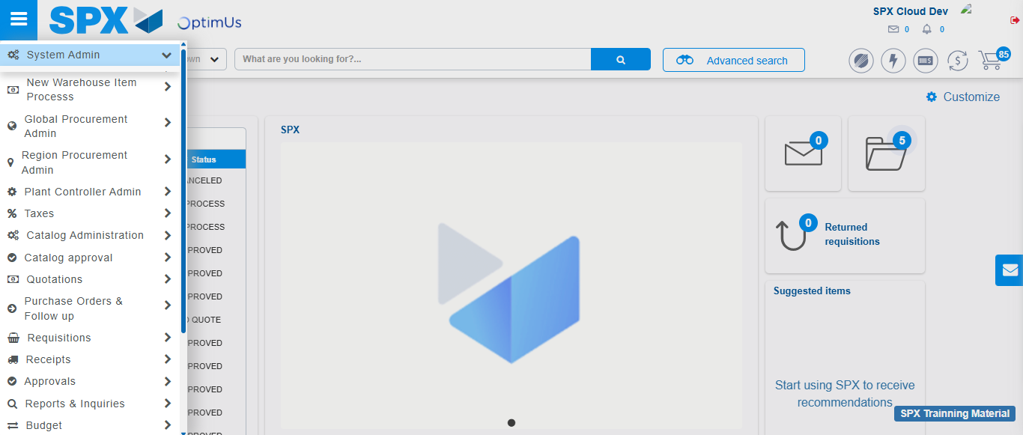Image file-name: QC_Testing-tc007_SPX_Dev5_Validacion_Boton_Edit_Administrador_Menu-nov. 20 2025, 03 43 22 p. m.

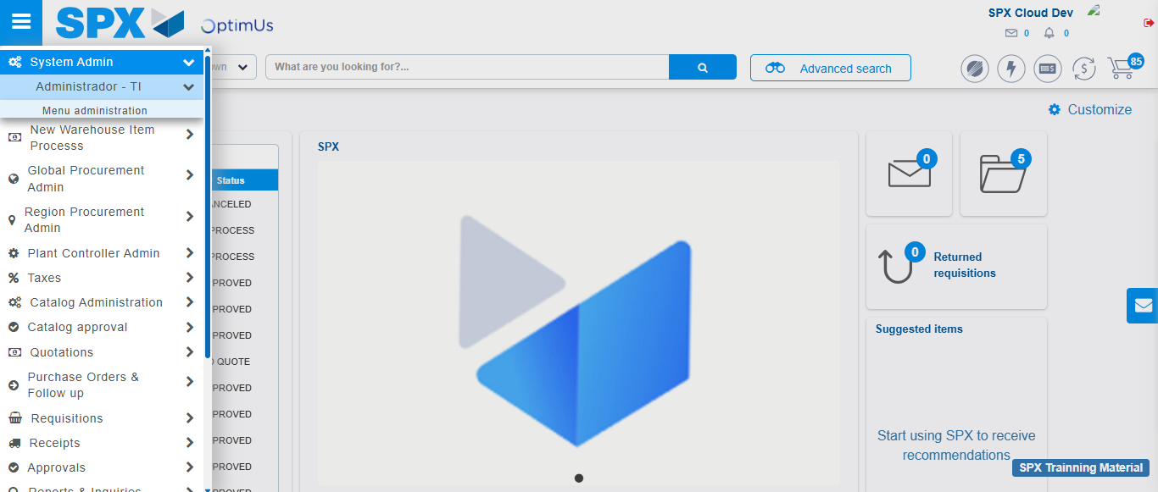Image file-name: QC_Testing-tc007_SPX_Dev5_Validacion_Boton_Edit_Administrador_Menu-nov. 20 2025, 03 43 23 p. m.

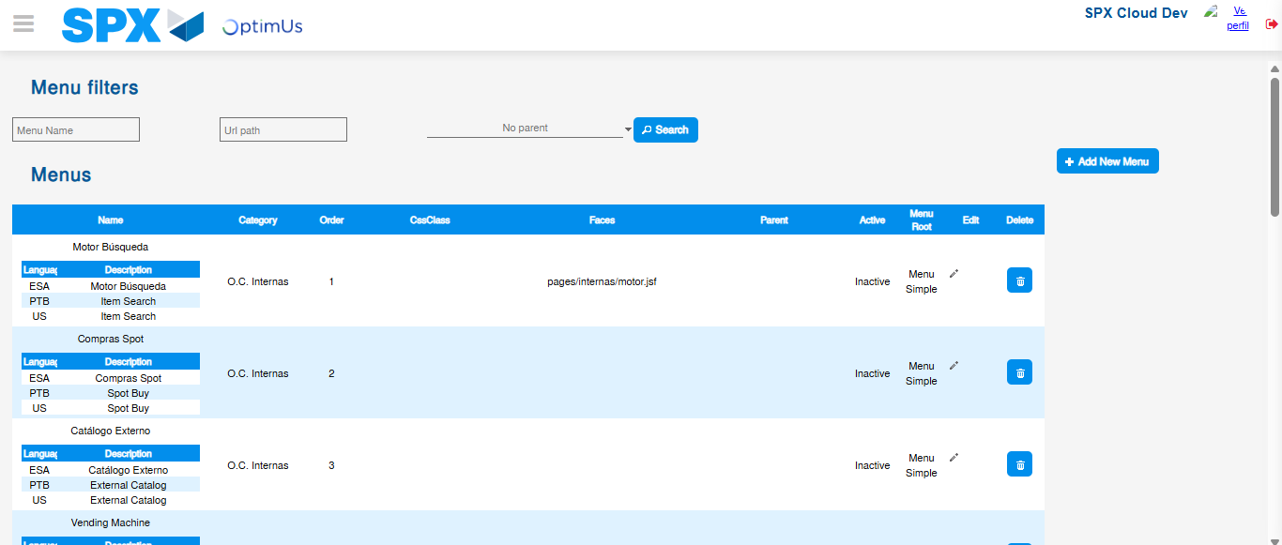Image file-name: QC_Testing-tc007_SPX_Dev5_Validacion_Boton_Edit_Administrador_Menu-nov. 20 2025, 03 43 26 p. m.

Step 3 - Add new menu and edit fields: New menu successfully registered
Image file-name: QC_Testing-tc007_SPX_Dev5_Validacion_Boton_Edit_Administrador_Menu-nov. 20 2025, 03 43 26 p. m.

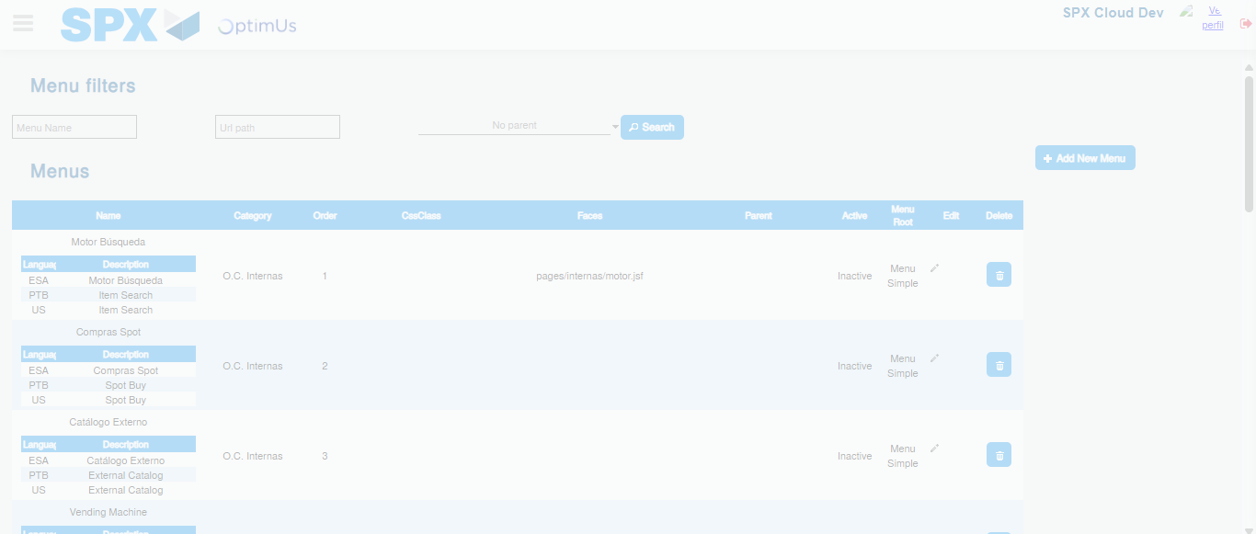Image file-name: QC_Testing-tc007_SPX_Dev5_Validacion_Boton_Edit_Administrador_Menu-nov. 20 2025, 03 43 27 p. m.

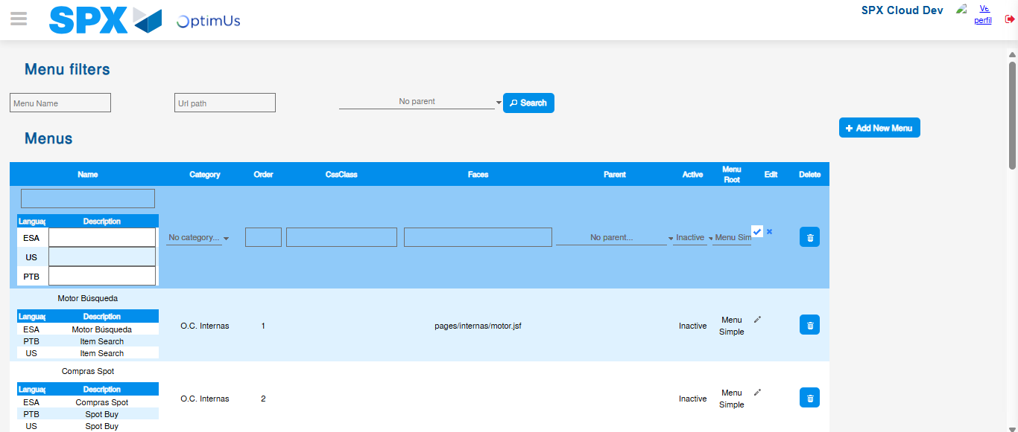Image file-name: QC_Testing-tc007_SPX_Dev5_Validacion_Boton_Edit_Administrador_Menu-nov. 20 2025, 03 43 30 p. m.

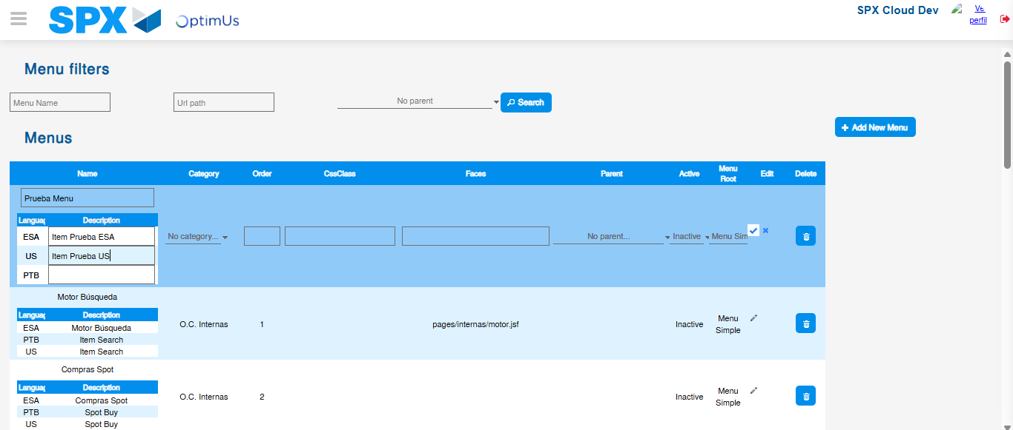Image file-name: QC_Testing-tc007_SPX_Dev5_Validacion_Boton_Edit_Administrador_Menu-nov. 20 2025, 03 43 31 p. m.

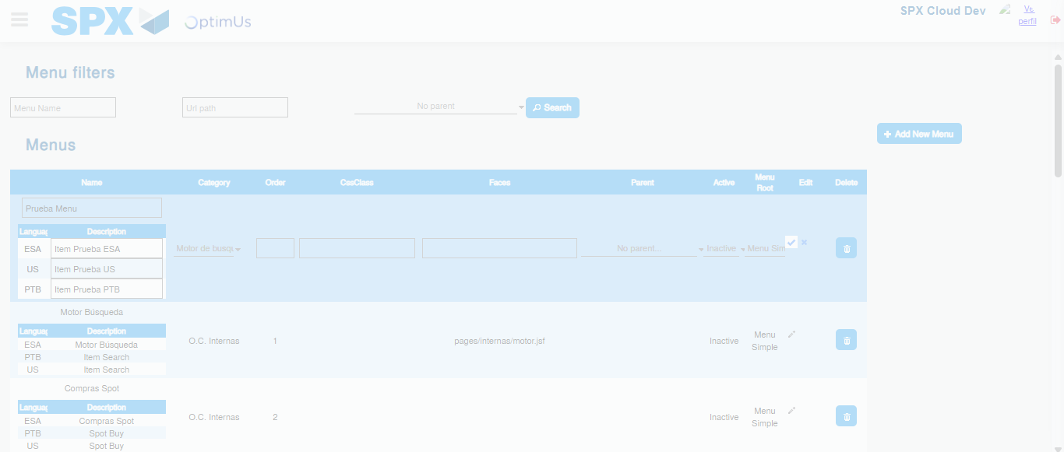Image file-name: QC_Testing-tc007_SPX_Dev5_Validacion_Boton_Edit_Administrador_Menu-nov. 20 2025, 03 43 32 p. m.

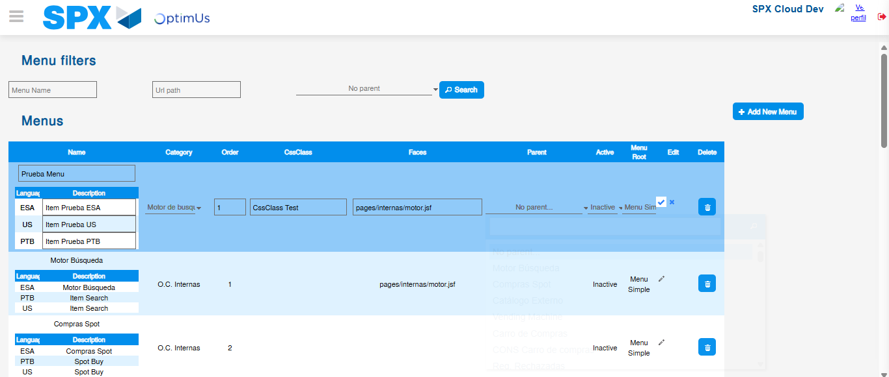Image file-name: QC_Testing-tc007_SPX_Dev5_Validacion_Boton_Edit_Administrador_Menu-nov. 20 2025, 03 43 33 p. m.

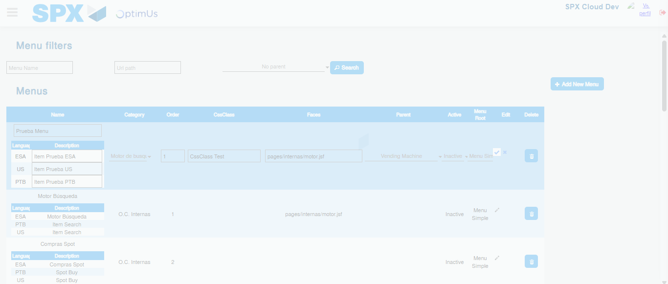Image file-name: QC_Testing-tc007_SPX_Dev5_Validacion_Boton_Edit_Administrador_Menu-nov. 20 2025, 03 43 34 p. m.

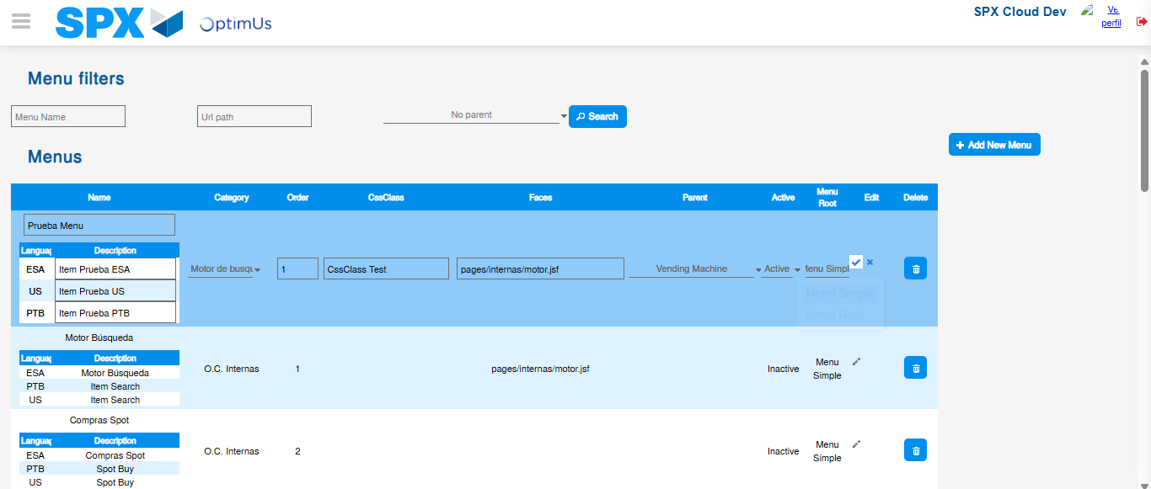Image file-name: QC_Testing-tc007_SPX_Dev5_Validacion_Boton_Edit_Administrador_Menu-nov. 20 2025, 03 43 35 p. m.

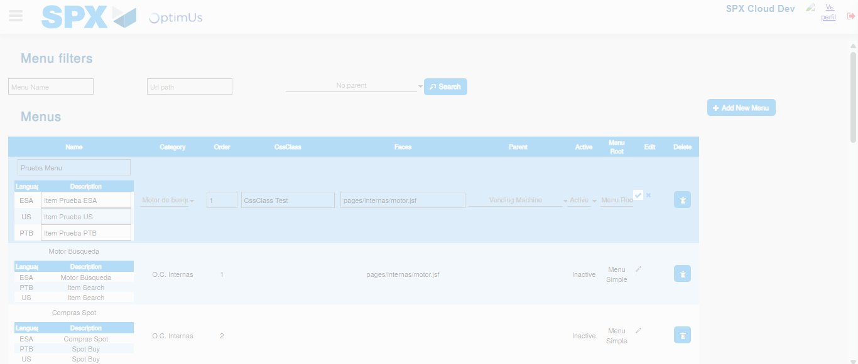Image file-name: QC_Testing-tc007_SPX_Dev5_Validacion_Boton_Edit_Administrador_Menu-nov. 20 2025, 03 43 36 p. m.

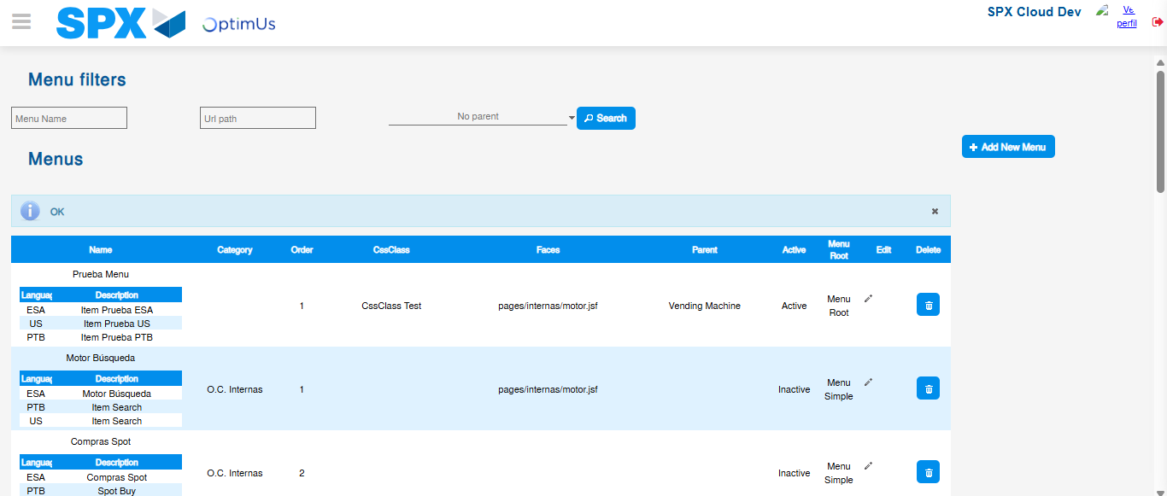Image file-name: QC_Testing-tc007_SPX_Dev5_Validacion_Boton_Edit_Administrador_Menu-nov. 20 2025, 03 43 39 p. m.

